Terraform 05
- Watch the Terraform-05 video

1. Terraform Remote State with S3 + DynamoDB (State Locking)
What it does
- S3 stores the Terraform state file (terraform.tfstate)
- DynamoDB provides state locking to prevent concurrent apply/plan runs

DynamoDB Table (for locking)

- Partition key: LockID (String)

resource "aws_dynamodb_table" "terraform_locks" {
name = "terraform-state-locks"
billing_mode = "PAY_PER_REQUEST"
hash_key = "LockID"

attribute {
name = "LockID"
type = "S"
}
}

- S3 Bucket (for state)

resource "aws_s3_bucket" "terraform_state" {
bucket = "my-terraform-state-bucket"
}

- S3 bucket versioning (for state)

resource "aws_s3_bucket_versioning" "versioning" {
bucket = aws_s3_bucket.terraform_state.id

versioning_configuration {
status = "Enabled"
}
}

- Backend Configuration

terraform {
backend "s3" {
bucket = "my-terraform-state-bucket"
key = "envs/prod/terraform.tfstate"
region = "us-east-1"
dynamodb_table = "terraform-state-locks"
encrypt = true
}
}
Result
- State stored in S3
- Lock created in DynamoDB during plan/apply
- Lock automatically released on success or failure

2. Terraform State Lock Behavior
Action | Result
terraform apply | Acquires DynamoDB lock
Another apply runs | Fails with lock error
Crash/timeout | Lock may remain
Manual unlock | terraform force-unlock <LOCK_ID>

Force Unlock
terraform force-unlock <LOCK_ID>
Only use when you are sure no other Terraform run is active.

3. Terraform Provisioners
Provisioners run after a resource is created (or before destroy).
Best practice: Avoid provisioners when possible. Prefer:
- User data
- Configuration management
- Cloud-native bootstrapping

local-exec
Runs a command on the machine running Terraform

provisioner "local-exec" {
command = "echo ${self.public_ip} >> ips.txt"
}

remote-exec
Runs commands on the created resource
provisioner "remote-exec" {
inline = [
"sudo yum update -y",
"sudo yum install -y nginx",
"sudo systemctl start nginx"
]
}
Requires a connection block:

connection {
type = "ssh"
user = "ec2-user"
private_key = file("key.pem")
host = self.public_ip
}

Provisioner on Destroy

provisioner "local-exec" {
when = destroy
command = "echo Instance destroyed"
}

4. Common Terraform Commands
Initialization
terraform init
terraform init -reconfigure
terraform init -upgrade

Planning & Applying
terraform plan
terraform plan -out=tfplan
terraform apply
terraform apply tfplan
terraform apply -auto-approve

State & Locking
terraform state list
terraform state show <resource>
terraform state rm <resource>
terraform force-unlock <LOCK_ID>

Validation & Formatting
terraform validate
terraform fmt
terraform fmt -recursive

Destroy
terraform destroy
terraform destroy -auto-approve

- Execute the script shown in the video.

- Create s3 bucket using terraform

provider "aws" {
region = "ap-south-1"
}

resource "aws_s3_bucket" "s3_bucket" {
bucket = "s3backend-shahbaz-123"
}

resource "aws_s3_bucket_ownership_controls" "ownership" {
bucket = aws_s3_bucket.s3_bucket.id

rule {
object_ownership = "BucketOwnerEnforced"
}
}
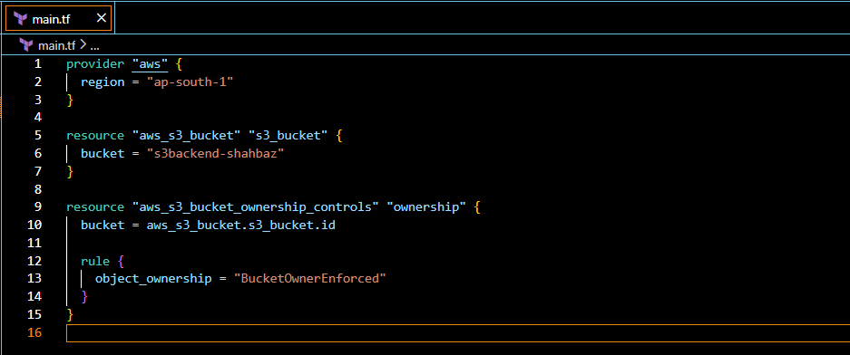
- terraform init
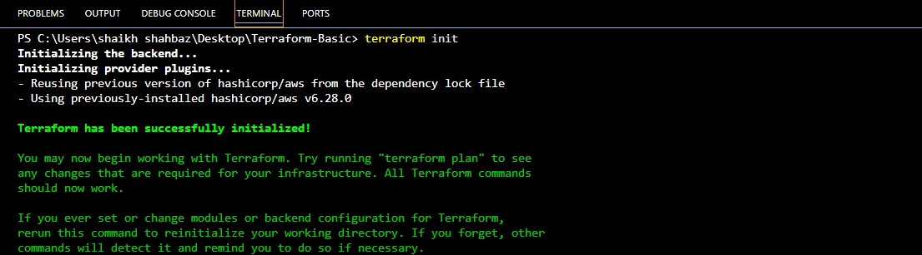
- terraform apply
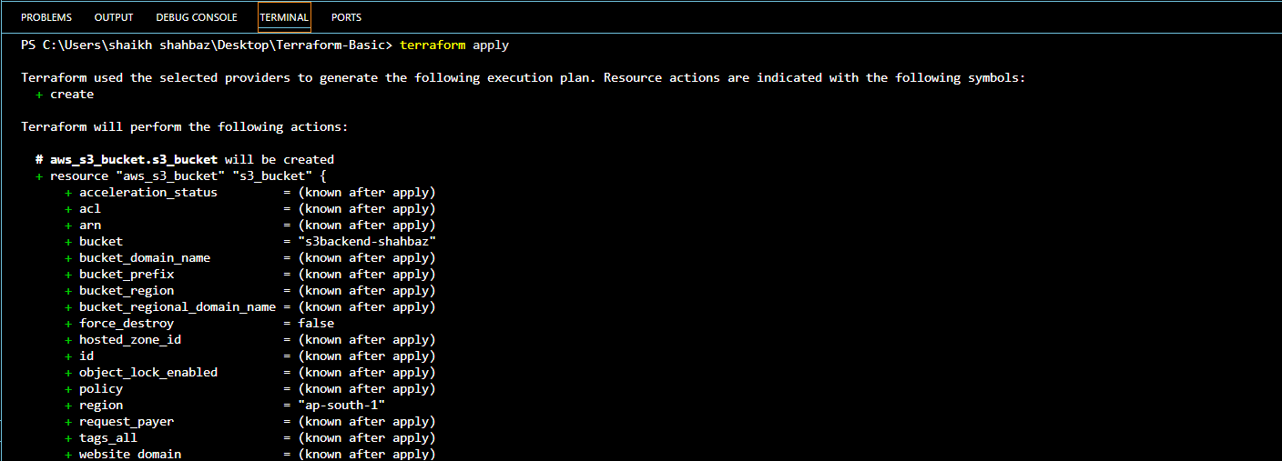
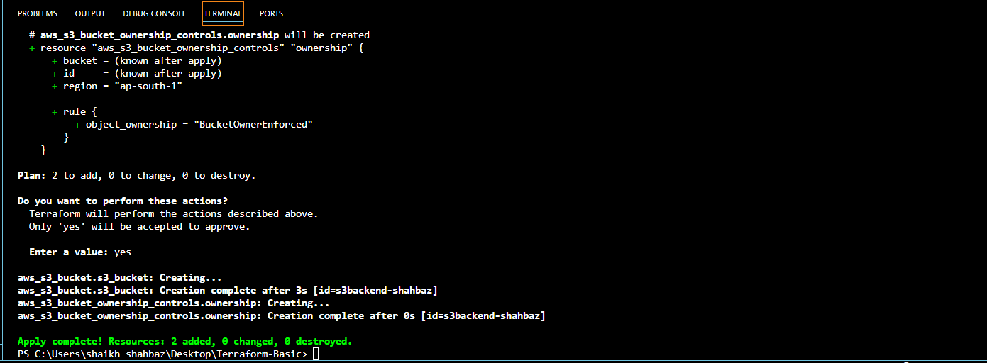
Check in Your AWS account
Go to s3 buckets
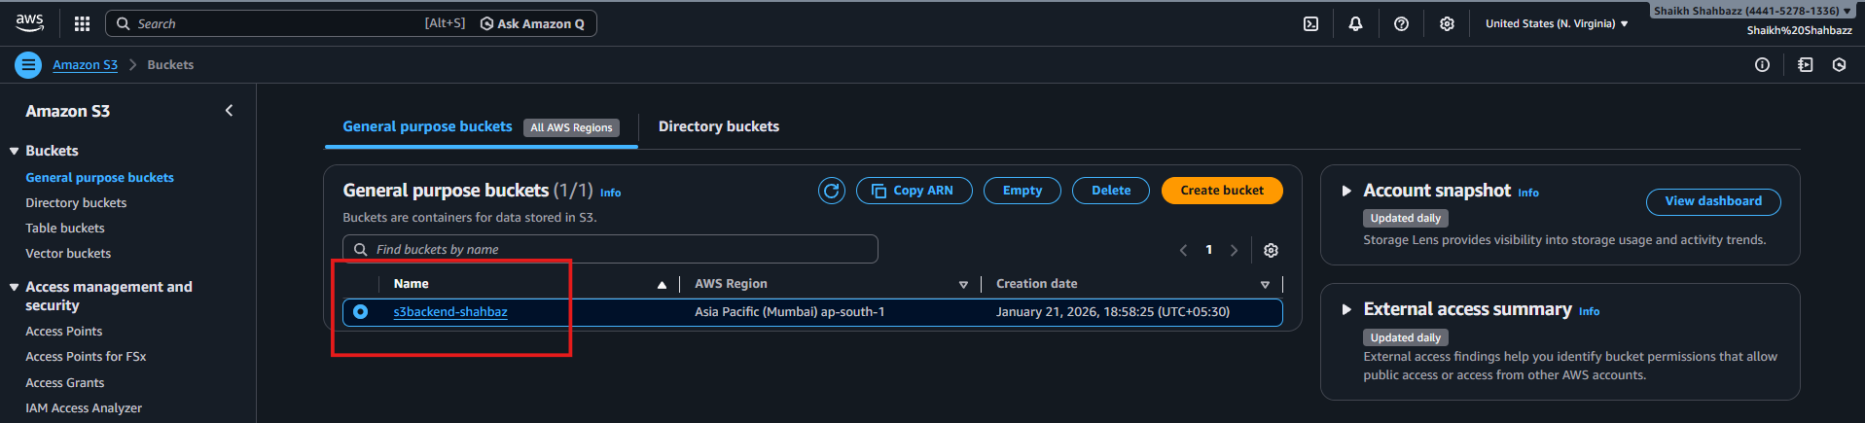

- Create dynamo db using terraform

resource "aws_dynamodb_table" "dynamodb-terraform-state-lock" {
name = "terraform-state-lock-dynamo"
hash_key = "LockID"
read_capacity = 20
write_capacity = 20

attribute {
name = "LockID"
type = "S"
}
}

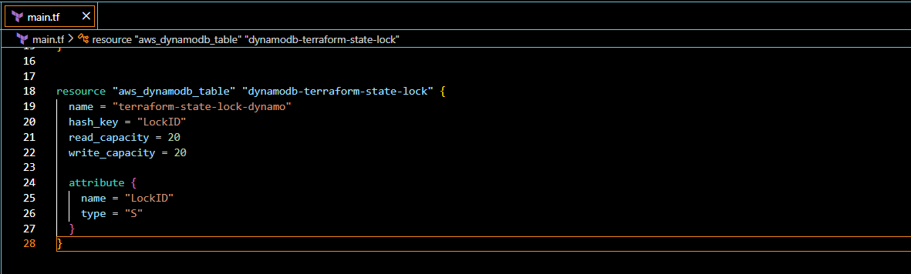
- terraform init
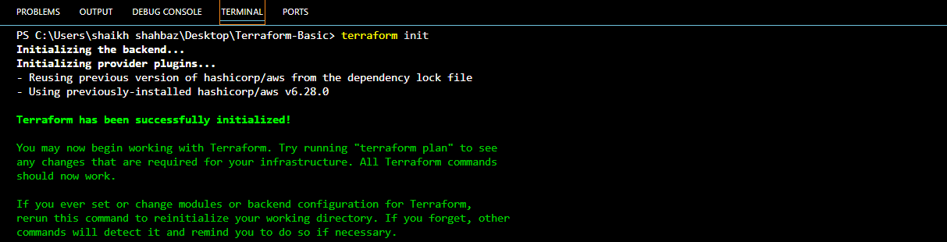
- terraform apply
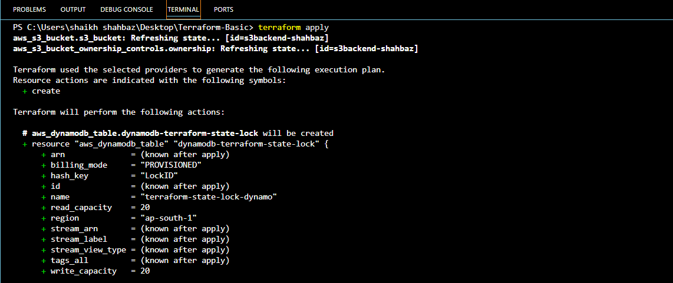
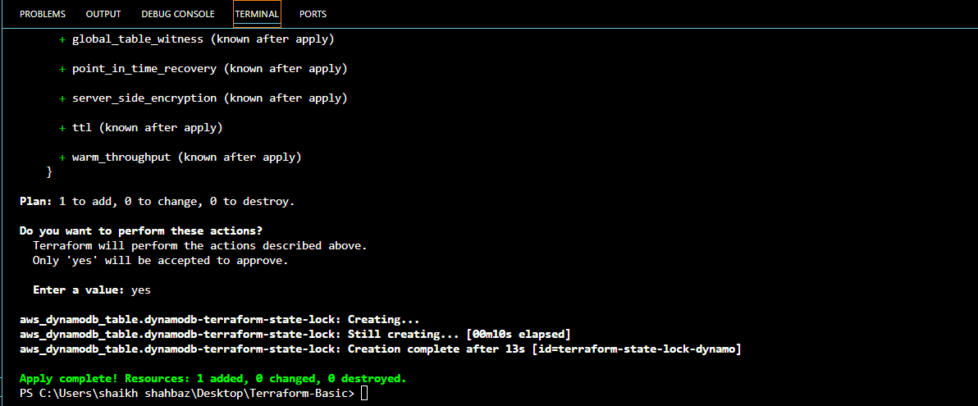
Check In your AWS account
Goto DynamoDB tables
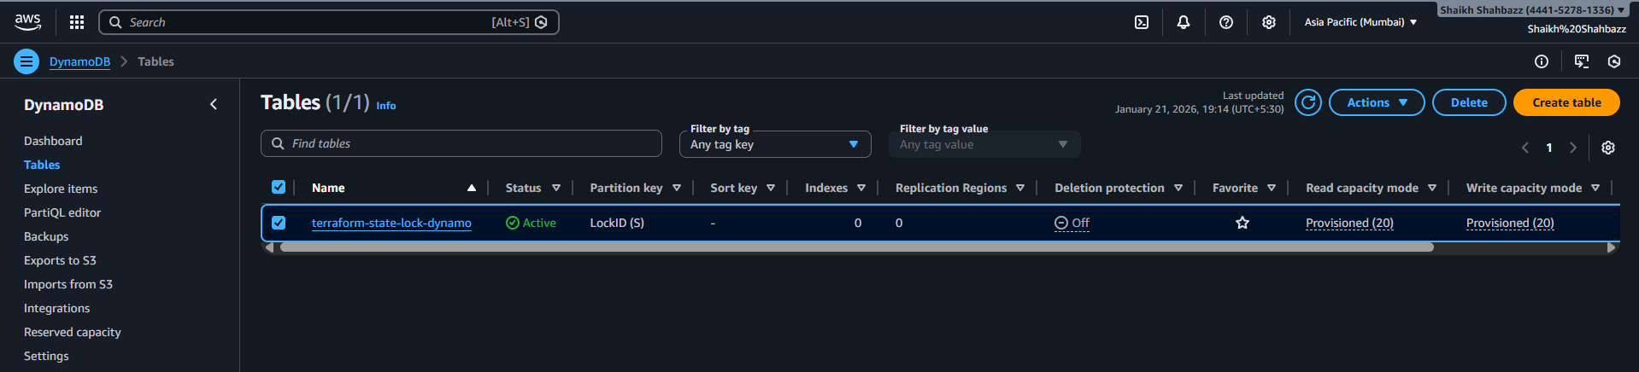

- S3 as backend for terraform.tfstate file

terraform {
backend "s3" {
bucket = "s3backend-shahbaz"
dynamodb_table = "terraform-state-lock-dynamo"
key = "terraform.tfstate"
region = "ap-south-1"
}
}

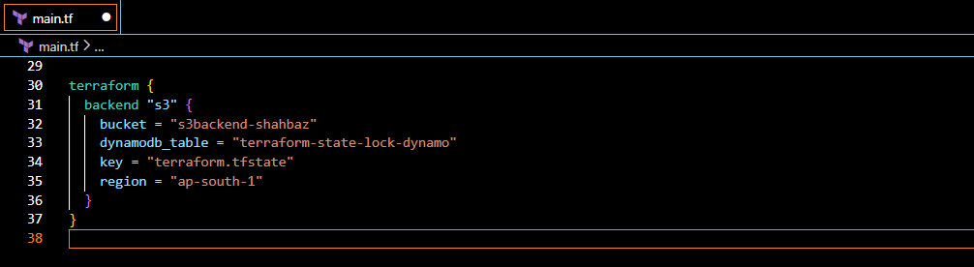
- terraform init
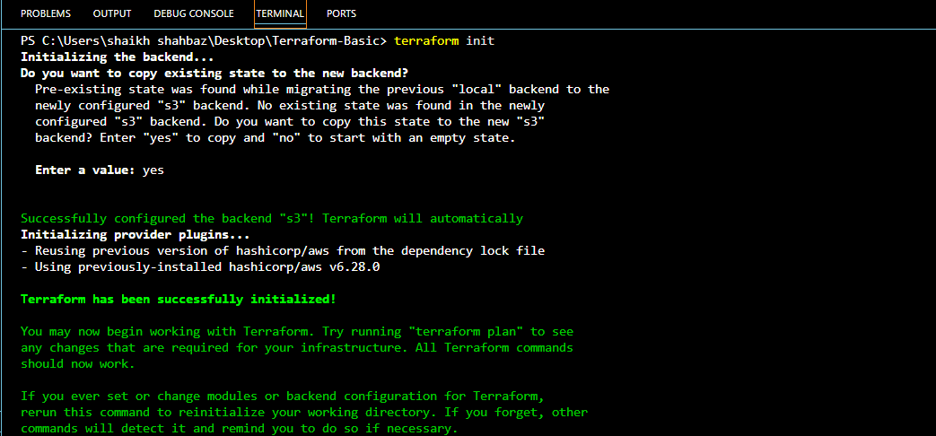
- terraform apply
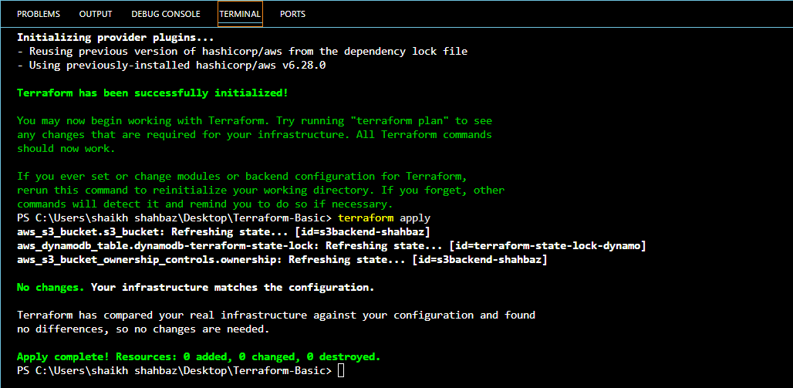
Check in your AWS account
Goto s3 bucket select your bucket terraform.tfstate
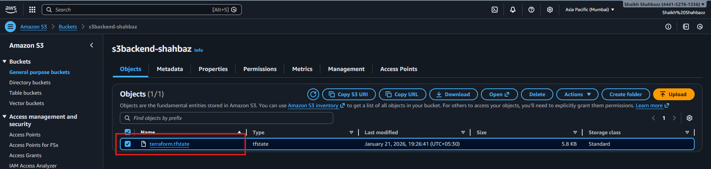
And also check for DynamoDB table
Goto DynamoDB select your table
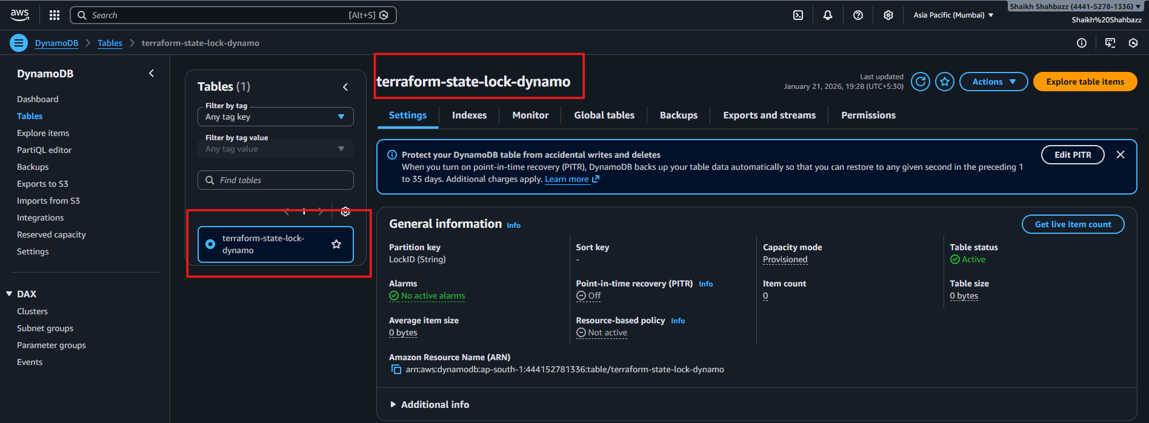

- Create Ec2 instance using terraform

resource "aws_instance" "webserver" {
ami = "ami-07ff62358b87c7116"
instance_type = "t2.micro"
key_name = "jenkins"

tags = {
name = "First-server"
}
}
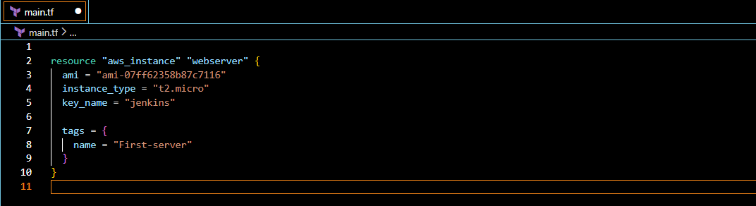
- terraform init
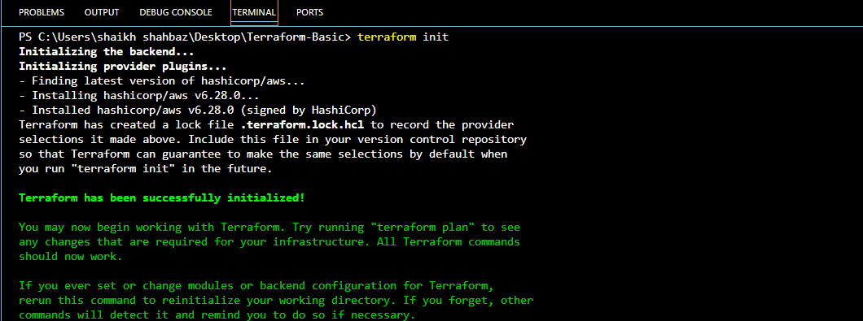
- terraform apply
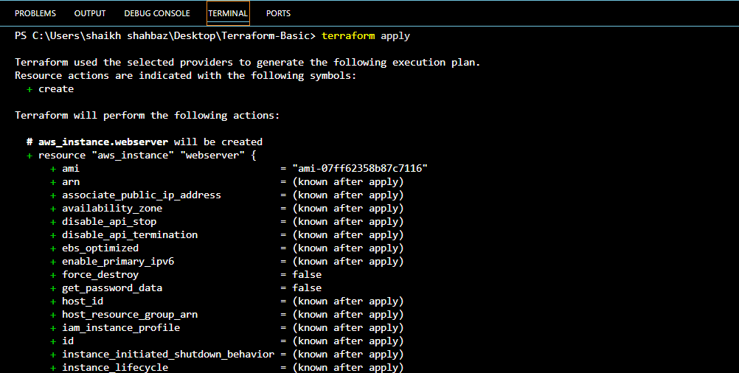
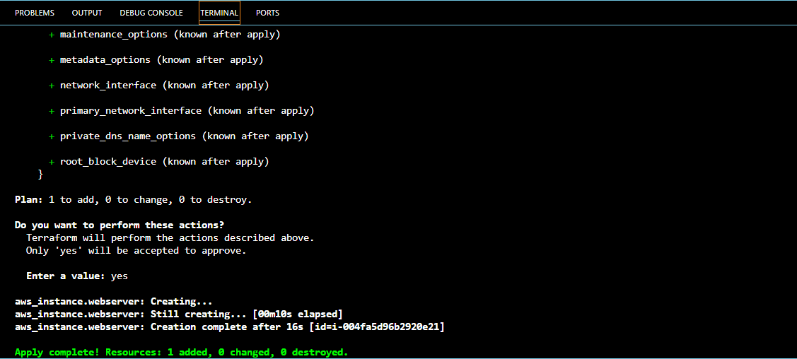
Check in Your AWS account
Goto Ec2 instances <First-server>
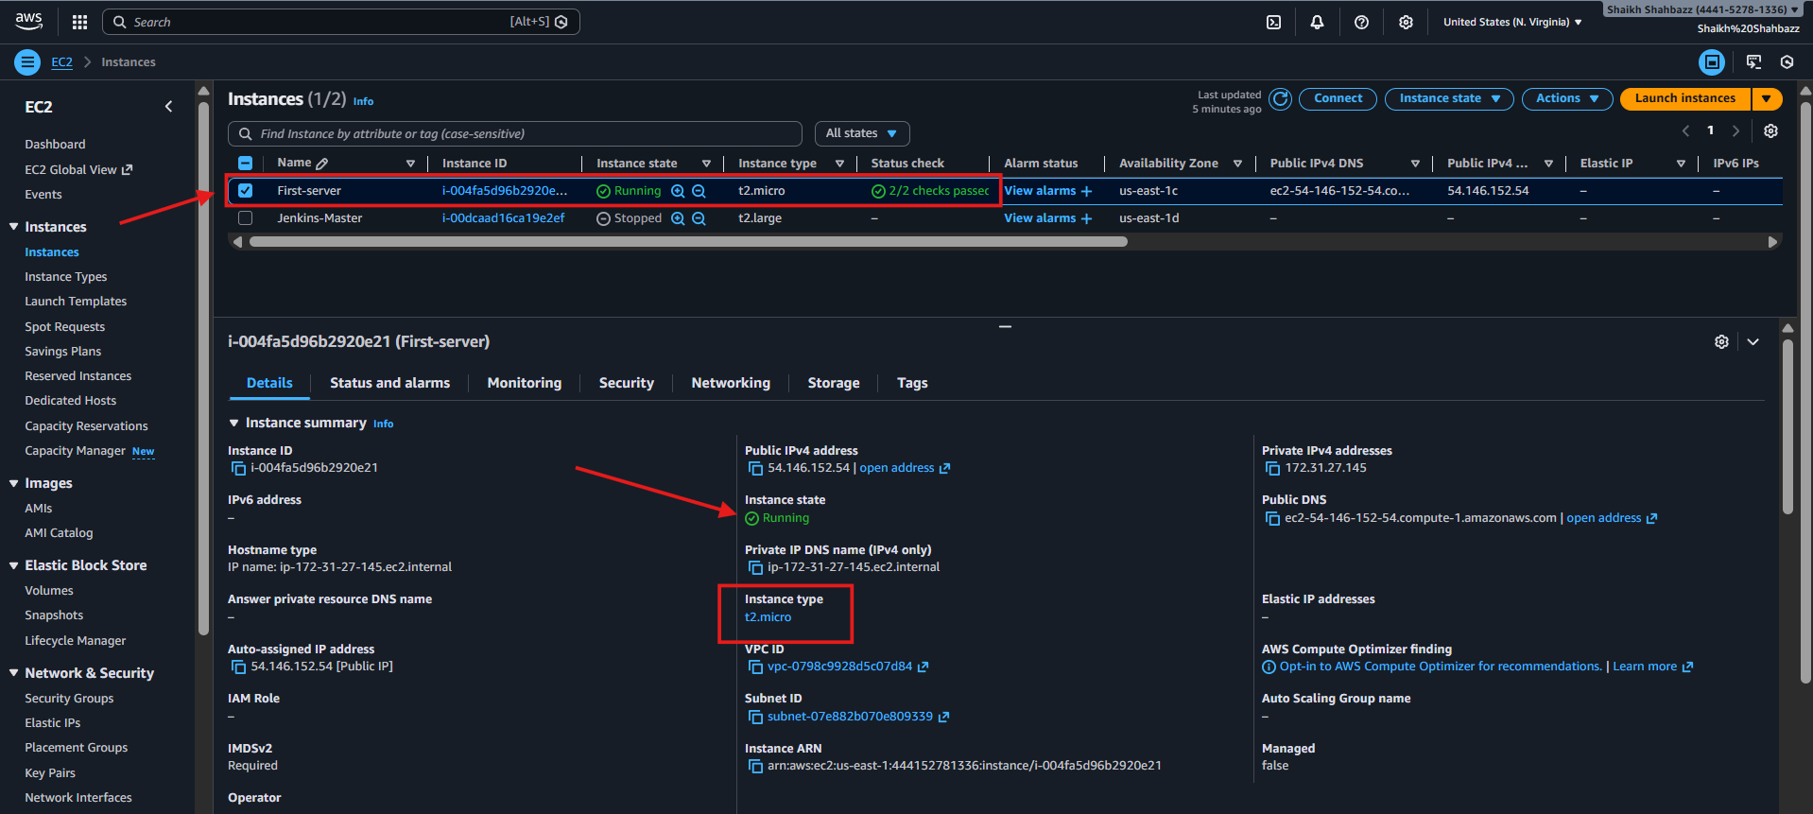

4.Create one EC2 instance with httpd installed using a Terraform script.
Launch one ec2 instance with apache (httpd) installed in it.

Use below Block-type:
resource "aws_instance" "webserver" {
ami = "ami-07ff62358b87c7116"
instance_type = "t2.micro"
key_name = "jenkins"
user_data = <<-EOF
#!/bin/bash
sudo yum update -y
sudo yum install -y httpd
sudo systemctl start httpd
sudo systemctl enable httpd
echo "Hello, World from $(hostname -f)" > /var/www/html/index.html
EOF
tags = {
Name = "httpd-instance"
}
provisioner "local-exec" {
command = "echo ${aws_instance.httpd.public_ip} > ip_address.txt"
}
}

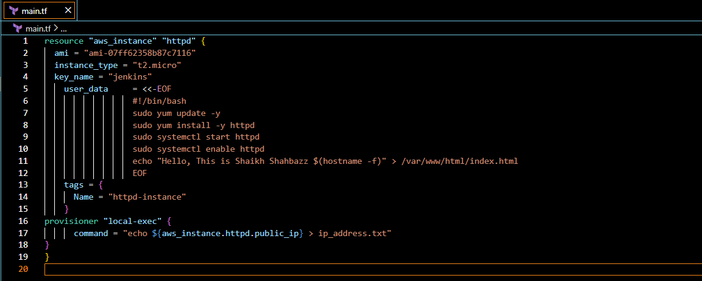
- terraform init
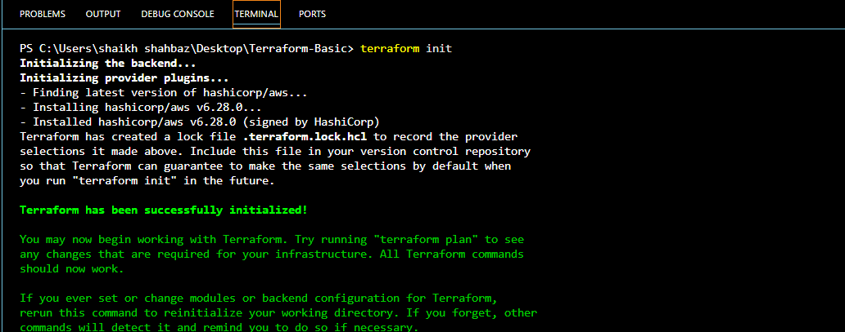
- terraform apply

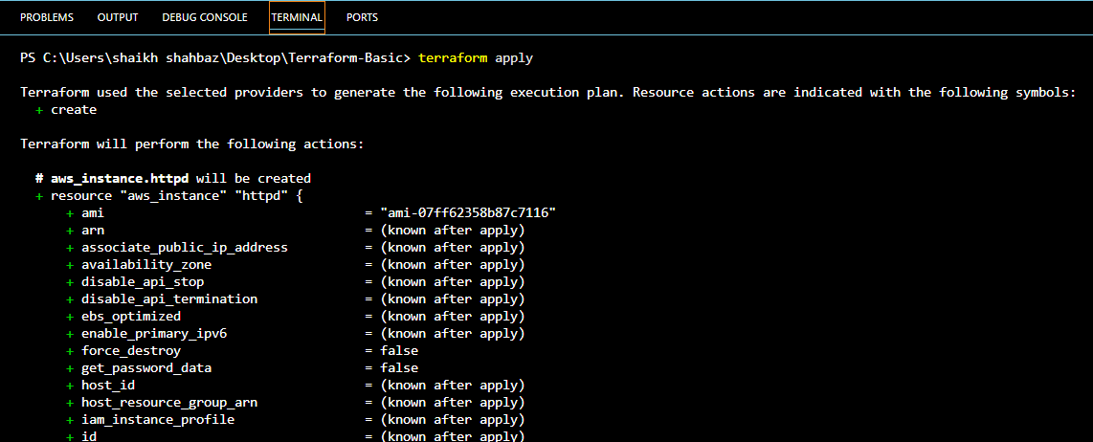
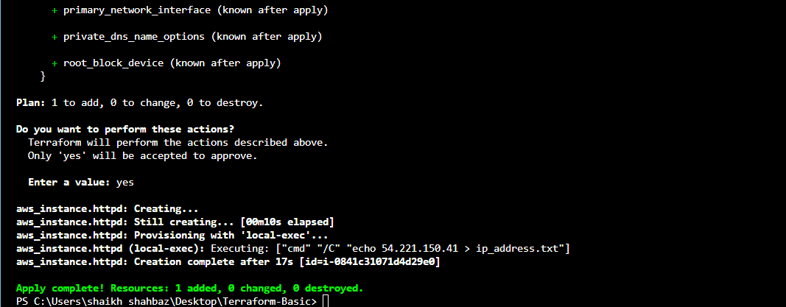
Check in Your AWS account
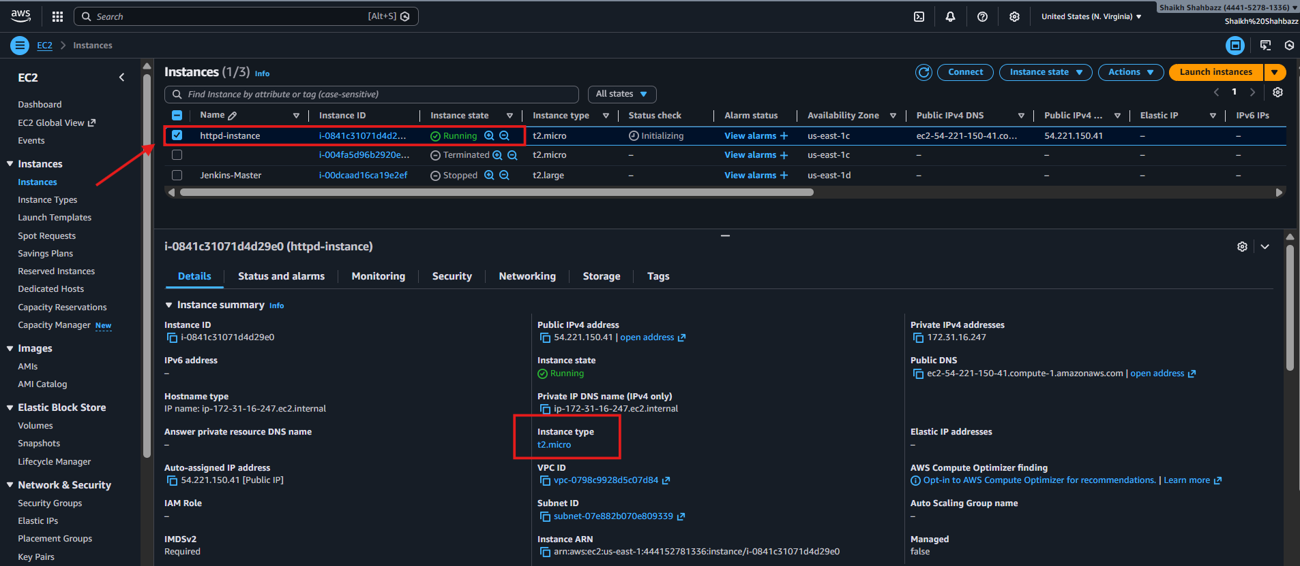
We can see public ip of our launched instance
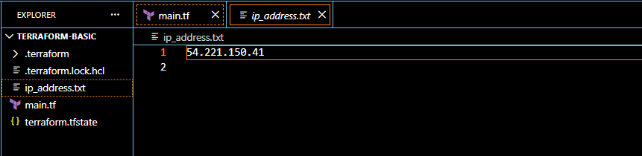
Validate: In Browser http://54.221.150.41/
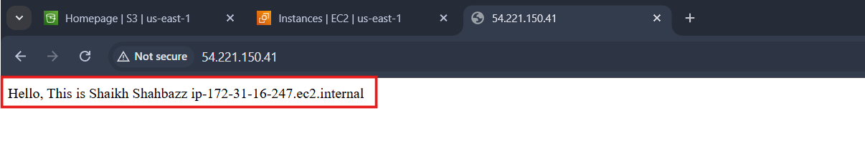

- Set up S3 as backend for task 3.

terraform {
backend "s3" {
bucket = "s3backend-shahbaz"
dynamodb_table = "terraform-state-lock-dynamo"
key = "terraform.tfstate"
region = "ap-south-1"
}
}


- terraform init

- terraform apply

Check in your AWS account
Goto s3 bucket select your bucket terraform.tfstate

And also check for DynamoDB table
Goto DynamoDB select your table


- Set up DynamoDB locking for task 3.

resource "aws_dynamodb_table" "dynamodb-terraform-state-lock" {
name = "terraform-state-lock-dynamo"
hash_key = "LockID"
read_capacity = 20
write_capacity = 20

attribute {
name = "LockID"
type = "S"
}
}


- terraform init

- terraform apply


Check In your AWS account
Goto DynamoDB tables

And also check for DynamoDB table
Goto DynamoDB select your table


